4. sz. függelék - Régészeti lelőhelyek
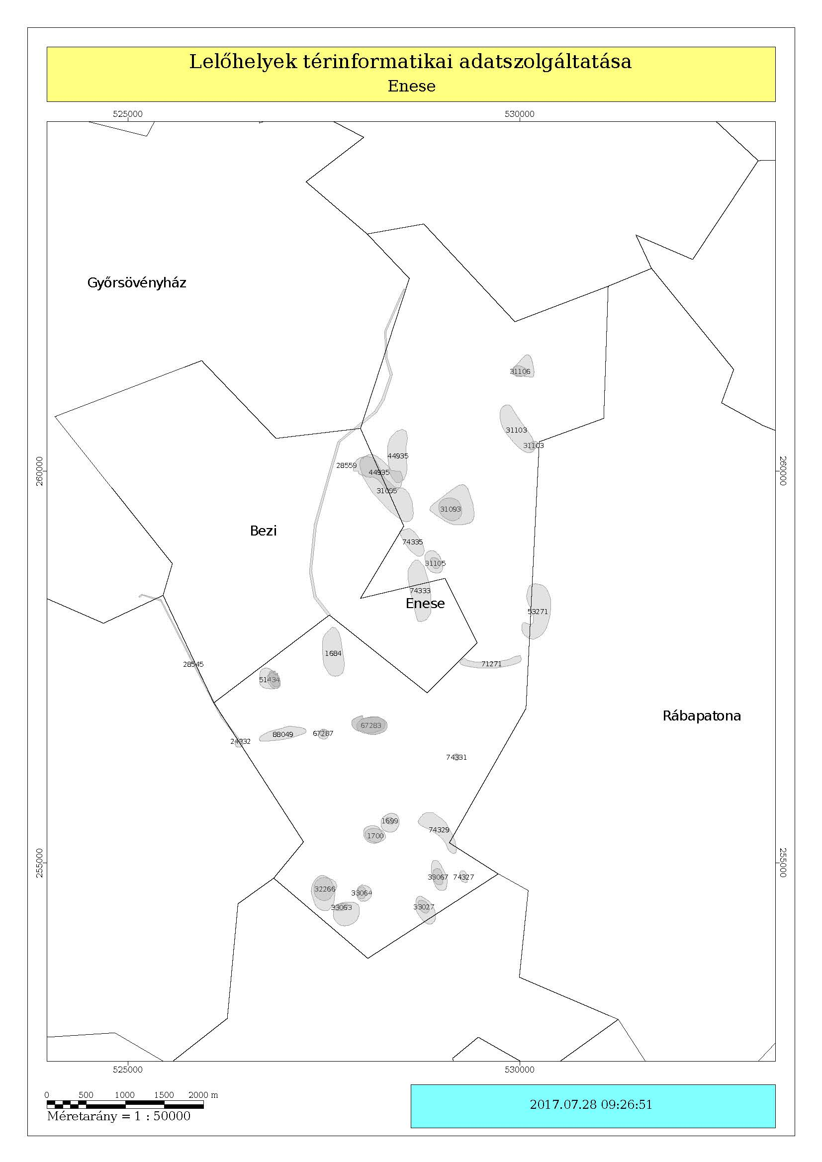

azonosító | település | név | HRSZ | EOV Y koordináta | EOV X koordináta
28559 | Bezi | Csatornarendszer XVII. | 0136, 0134/1, 0245, 0233/7, 0137/1, 0137/3, 0134/7, 0134/8, 0137/4, 0137/5, 0137/6, 0233/8, 061, 067/2, 062, 059, 058/4, 058/2, 056, 054, 052/6, 053, 040/11, 040/15, 095/20, 095/21, 062, 065, 095/19, 067/1, 040/16, 040/17, 040/18, 068/17, 095/23, 095/22, 040/19, 040/21, 040/20, 075, 073/3, 067/2, 067/3, 072, 073/1, 064, 073/2, 063, 078/2, 039 | 527654 | 260236
31095 | Bezi | Faluhely-puszta I. | 0132/4, 068/2, 068/4, 068/5, 068/6, 068/18, 068/19, 092/1, 092/2, 068/13, 068/14, 068/15, 068/16, 068/1, 091, 081/2 | 528306 | 259751
74333 | Bezi | Kastély-tábla | 0116, 0115/4, 0117/7, 0153 | 528728 | 258472
1684 | Enese | Szabadság utca 72. | 57/9, 57/11, 57/10, 67/1, 66/1, 65/1, 68/1, 55, 098/9, 098/10, 098/11, 098/12, 098/13, 098/14, 098/15, 098/20, 098/21, 91/2, 92/2, 71, 95, 58/1, 57/1, 92/1, 82, 81, 56, 96, 79, 80, 78, 59/1, 70/1, 57/17, 64/1, 63/1, 62/1, 61/1, 60/1, 77, 76, 75, 74, 73, 57/12, 57/6, 57/7, 57/8, 57/13, 57/18, 57/19, 57/20, 57/21, 57/22, 57/23, 57/3, 57/4, 57/5, 57/16, 35, 33, 32, 31, 36, 21/1, 21/6, 29, 30, 21/2, 57/14, 57/15, 110, 109/1, 109/2, 108, 102, 107, 100, 101, 103, 94/2, 20, 46, 104, 105, 113/2, 113/1, 45, 48, 47, 94/1, 106, 97, 98, 99, 34, 54, 53, 52, 51, 50, 49, 44, 43, 42, 41, 40, 39, 38, 37, 28, 27, 26, 25, 0102/4, 098/8, 0102/2, 098/17, 0102/1, 098/7, 0102/3, 0102/5 | 527620 | 257677
1699 | Enese | Varga tag | 059/6, 059/7, 059/9, 059/5 | 528348 | 255507
1700 | Enese | Varga tag II. | 059/6, 059/7, 059/5, 059/9 | 528128 | 255360
51434 | Enese | Pippani-dűlő | 092/17, 092/18, 092/19, 092/20, 092/23, 092/24, 093/15, 093/25, 093/27, 093/29, 092/13, 092/14, 092/15, 092/16, 093/7, 093/10, 093/11, 093/13, 092/9, 091/2, 091/3, 093/14, 093/2, 093/3, 093/30, 093/32, 094/18, 094/20 | 526870 | 257343
67283 | Enese | Kiskerti-dűlő | 203, 222/1, 226, 223/1, 223/2, 224/1, 233/2, 233/1, 232, 231, 222/2, 234, 240, 224/2, 442/1, 442/5, 243, 442/6, 242, 241, 221/1, 220, 230, 221/2 | 528088 | 256755
67287 | Enese | Eper u. 3. | 316, 317/2, 313, 317/3, 317/4, 311, 312, 309/4, 309/3, 072, 073, 074/6, 074/5, 074/3, 074/2 | 527495 | 256638
71271 | Enese | Külső-Réti-dűlő | 05/29, 05/30, 05/32, 05/33, 05/36, 05/39, 05/40, 05/43, 05/44, 06/10, 06/11, 06/12, 06/13, 06/14, 06/15, 06/16, 06/17, 06/18, 06/19, 06/20, 06/21, 06/22, 06/23, 06/24, 06/25, 06/26, 06/27, 06/28, 06/29, 06/30, 06/31, 06/32, 06/33, 06/34, 06/35, 06/36, 07/11, 07/12, 07/13, 07/14, 07/15, 07/16, 07/21, 07/22, 07/23, 07/24, 07/25, 07/26, 07/27, 06/8, 06/9, 06/1, 06/2, 06/3, 06/4, 06/5, 06/6, 06/7, 07/7, 07/6, 07/8, 07/5, 07/4, 07/3, 05/20, 05/13, 05/14, 05/15, 05/18, 05/19 | 529642 | 257543
44935 | Enese | Győri-dűlő | 068/5, 068/6, 068/13, 068/14, 068/15, 068/16, 0132/4, 0134/6, 0135, 0137/3, 0134/9, 0134/7, 0134/8, 0134/5, 0133, 0134/4, 0138, 072, 081/2 | 528204 | 259986
74327 | Enese | Szilos-dűlő | 0129/8 | 529285 | 254820
74329 | Enese | Varga-tag III. | 028, 047/11, 047/6, 053/1, 053/5, 053/2, 053/3, 053/4 | 528970 | 255424
74331 | Enese | Kováts-tag | 047/9, 047/10 | 529197 | 256348
74335 | Enese | Péterháza-puszta III. | 0132/4, 0141, 0132/5, 0155/4, 0146, 0149 | 528635 | 259094
31093 | Enese | Péterháza-puszta, Erdőalja | 0164, 0167, 0166, 0163, 0162/3, 0147, 0162/2 | 529180 | 259541
31103 | Enese | Belevár | 0170/2, 0183/4, 0183/3, 0174, 0170/1 | 529958 | 260525
31105 | Enese | Péterháza-puszta II. | 0154, 0153, 0157, 0155/4, 0141, 0155/5, 0155/2 | 528903 | 258836
31106 | Enese | Hugat-puszta | 0183/4, 0183/1, 0176/8, 0176/7, 0185, 0183/5 | 530061 | 261317
32266 | Enese | Fudi-puszta | 0115/7 | 527494 | 254609
33027 | Enese | Fudi-puszta 117,6 Mp. | 0105/1, 0178/8, 0178/7, 0178/6, 0178/5, 0142/2, 0106 | 528798 | 254390
33063 | Enese | Fudi-puszta III. | 0115/7, 0115/6, 0115/5, 0108/6, 0114, 0108/7, 0108/8, 0108/9, 0108/10 | 527789 | 254350
33064 | Enese | Fudi-puszta IV. | 0113/1, 0113/6, 0115/5, 0115/3 | 528013 | 254609
33067 | Enese | Hármashatár | 0129/3, 0129/6, 0129/8 | 528970 | 254828
88049 | Enese | Siráki-dűlő | 078/16, 078/18, 081, 080, 076/1, 078/17, 069/2, 078/19, 076/2 | 526977 | 256642
24332 | Kóny | Szapud-ér | 095/20, 095/14, 095/21, 0106, 068, 069/1, 080 | 526416 | 256514
28545 | Kóny | Csatornarendszer III. | 082, 087, 086, 099/113, 099/112, 0100, 099/118, 099/110, 099/109, 098/11, 096/1, 096/4, 096/3, 096/5, 097, 096/6, 096/2, 098/2, 098/3, 098/4, 098/5, 098/7, 098/6, 098/8, 099/100, 099/13, 099/99, 099/15, 099/16, 099/26, 099/27, 099/28, 099/29, 099/30, 099/25, 099/24, 099/23, 099/21, 099/22, 099/20, 099/19, 099/18, 099/17, 099/12, 099/51, 099/50, 099/53, 099/52, 099/41, 099/42, 099/43, 099/44, 099/45, 099/48, 099/46, 099/47, 099/49, 099/34, 099/35, 099/38, 099/37, 099/40, 099/39, 099/36, 099/33, 099/31, 099/32, 099/80, 099/81, 099/83, 099/82, 099/86, 099/78, 099/102, 099/77, 099/73, 099/74, 099/101, 099/75, 099/72, 099/71, 099/70, 099/79, 099/69, 099/68, 099/67, 099/111, 099/93, 099/98, 099/96, 099/95, 099/94, 024/2, 026/3, 027, 028/1, 028/6, 0317 | 525856 | 257501
53271 | Rábapatona | Szekeresi-dűlő | 0287/3, 0287/4, 0287/3, 0287/4, 0287/5, 0287/5, 0287/6 | 530232 | 258210

